Introduction

Have you ever wanted to create your own minecraft game and run it on a public server? In this class each student will build their own custom minecraft game plugin. This game will consists of a challenging maze complete with **boss monsters**, **special weapons** and **unique challenges**.

We will break this task into 3 sessions, each consisting of 8 classes:

1. Intro to Minecraft Events and Blockly Scriptcraft features
2. Building custom items and drop events for your maze
3. Add boss monsters and special game challenges to your maze

We will creat a plugin which is like a mod, but easier to make and easier to maintain.  
  
The plugins we make will be created using a scratch program I wrote called **Blockly-Scriptcraft**. It looks like this:

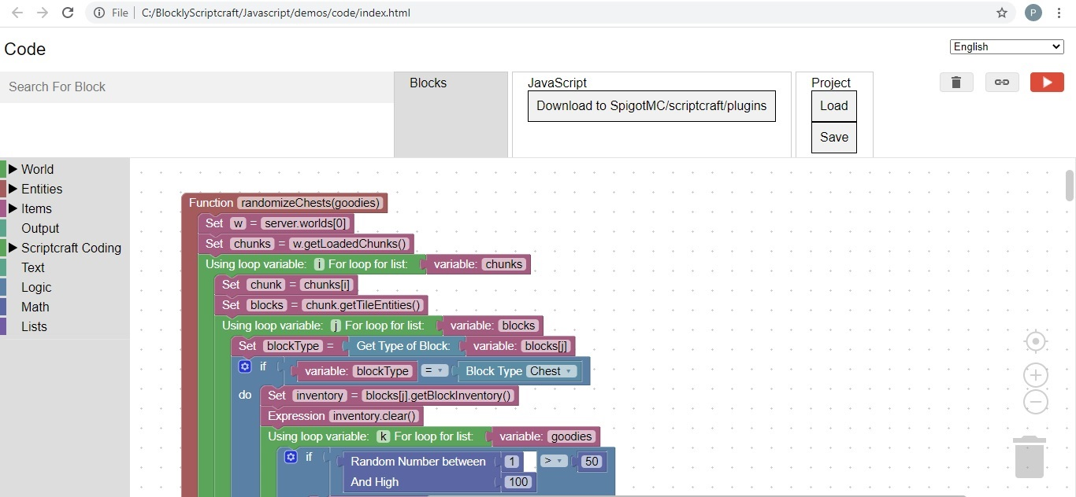

Some popular plugins you may already be aware of are: **Essentials**, **Grief Prevention**, and **World Edit**.  
We will create code in scratch and test the code on our own local minecraft server.  
We will also discuss how to install your game on a public (paid) server, so everyone can enjoy it.

Pre-Requisites

Before registering students should have:

Windows 10 computer (not MAC or iPad)

A Java minecraft paid account ($27) with microsoft

A microphone and speakers (or headset) connected to their computer

64-bit git for windows installed on their personal computer from: <https://git-scm.com/download/win>

Suggested age group: 8 to 16 years old

Windows 10 Setup

Git

Download 64-Bit Git for windows: <https://git-scm.com/download/win>

Run the git install executable

Local Minecraft Server and Blockly

Open a cmd window

Hold the Windows key and press the r key  
You should see:  
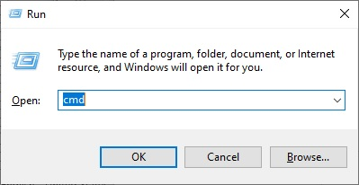

Enter the command: cmd  
You should see:  
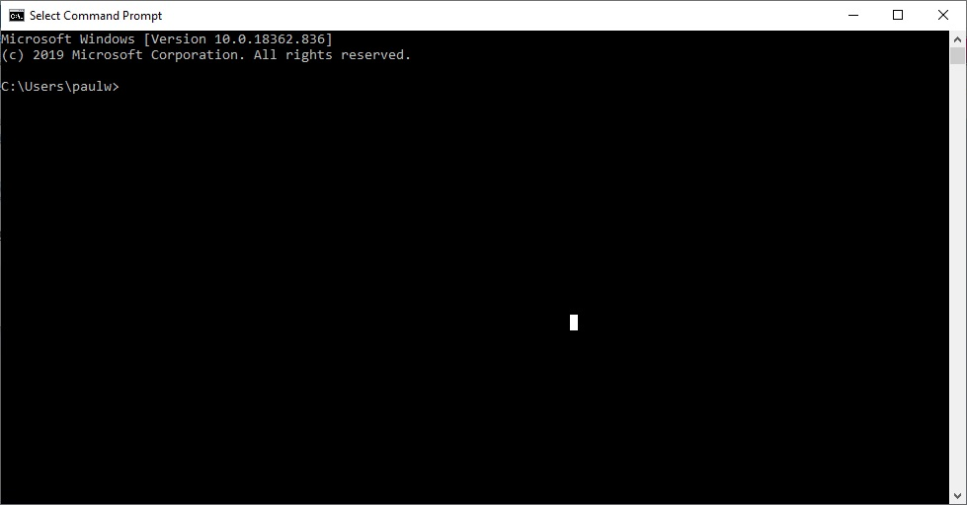

Enter the command:cd c:\

Enter the command:git clone https://www.github.com/Paulware/MinecraftServer

Enter the command:git clone https://www.github.com/Paulware/blocklyScriptcraft

Run the server by double-clicking the runServer.bat file in c:\MinecraftServer from windows explorer like:

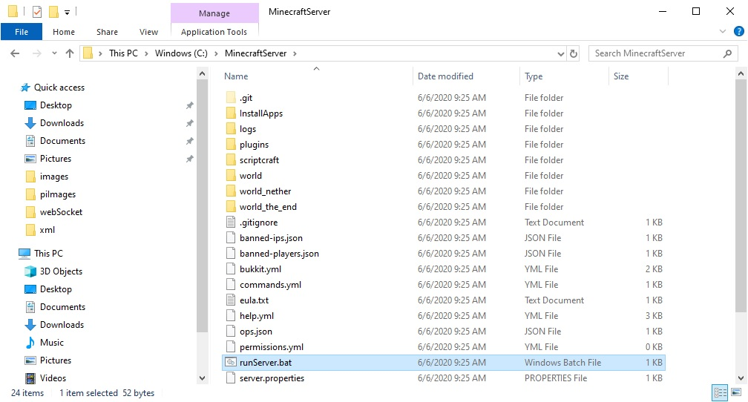

Run the scratch program by double-clicking C:\BlocklyScriptcraft\blocklyScriptcraft.html and open using google chrome like:  
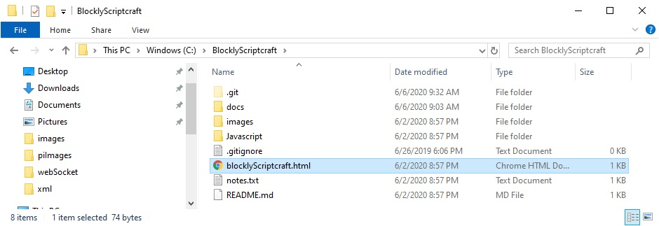

Blockly-Scriptcraft Overview

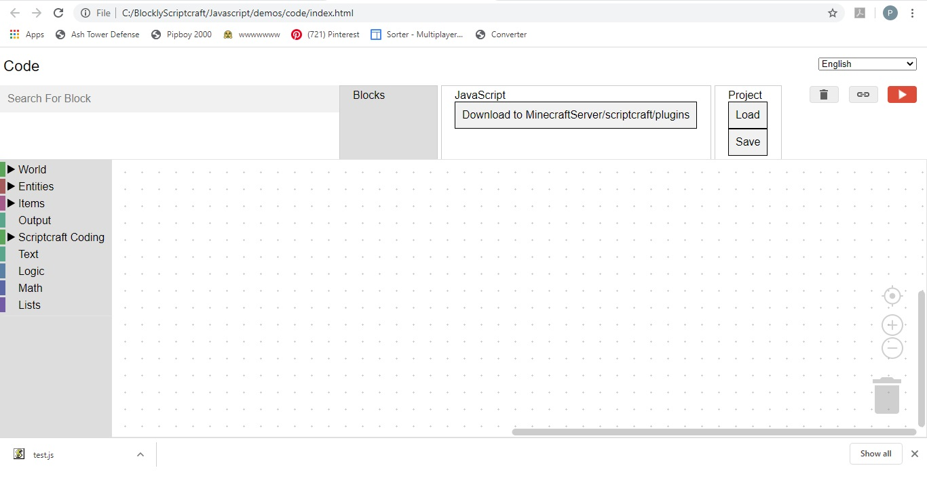**Blockly-Scriptcraft** will allow you to visually program a minecraft plugin just like you would make a scratch program  
This program should be run from the chrome browser only. To open it, double click on the blocklyScriptcraft.html file in the BlocklyScriptcraft directory on your personal computer  
On the left side is a menu that can be expanded to show sub-menus. Here you will find the blocks that you need to create your minigame

Above the menu is a Search For Block feature that will allow you find any block quickly. To try this out, type "function" into the Search for Block area. It should respond with: Function => Scriptcraft Coding, Functions. This means that the function block is found under the Scriptcraft Coding Menu, subMenu: Functions

To the right of the Search For Block feature are 3 tabs:

Blocks, which shows the current blocks being created

Javascript, which shows the javascript and allows you to download into the scriptcraft/plugins directory

Project, which allows you to save and load the current project block definitions

On the lower right is a trash can. You can drag blocks into the trash can to delete them. You can also delete or disable a block by right-clicking on the block and selecting delete or disable  
One useful feature is the duplicate block feature. You can duplicate a block, by right-clicking on the block and selecting duplicate.  
**Note:** The javascript is automatically created by Blockly-Scriptcraft. You will not need to manually edit this code.

After creating your blocks, click on the "Download to SpigotMC/scriptcraft/plugins" button, and save the file as test.js.  
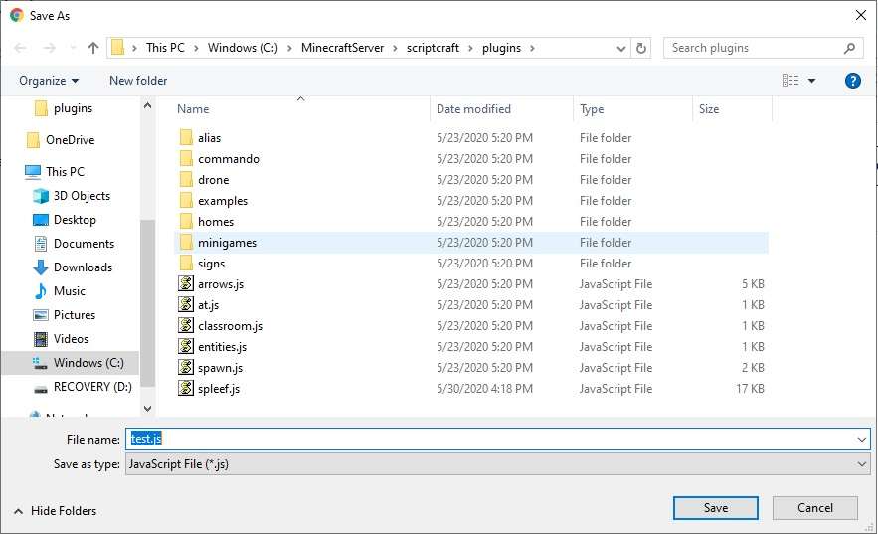  
The second time you press the "Download to SpigotMC/scriptcraft/plugins" button it will try to save to test.js(1) copy.  
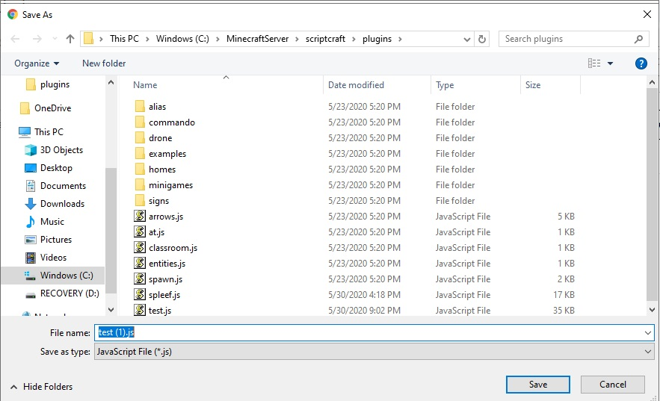  
**Do NOT use this option, it will confuse the server**, click on test.js and press ok to overwrite instead  
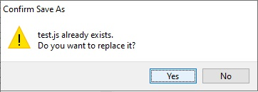  
This will place your code in an area that the minecraft server can find  
Next, in the server console window, execute the command: reload. This tells the server to read all the plugins that are available in the scriptcraft/plugins directory.  
Note: sometimes the server will show an error when you issue the reload command. This is an indicator that there is something wrong with the blocks.  
Next run your code by issuing the server command:  
js test()  
This allows you to test the function that you have just created in blockly-scriptcraft.  
Also at this time check the server window, sometimes error appear when the test function is executed. This is another indicator that there is something wrong with the blocks.

Session 1: Minecraft Events and Blockly-Scriptcraft

Class 1: Setup (described above)

Class 2:

Function Test

Test function is the standard block that we start our code with it is found in the Scriptcraft Coding area, in the Functions section

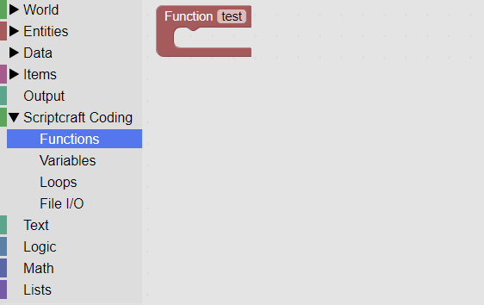

Drag and drop this function to the work area.

Send Message to Player

SendMessage is located in the Output area. Use this block to send a message to the player.

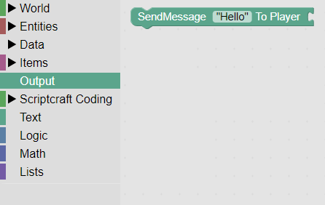

The variable block is located in the scriptcraft coding area it is used to pass data. 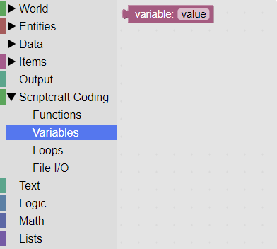

Putting these items together allows you to send a message to the player.

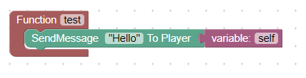

To test this code, press the download button:



Then select test.js

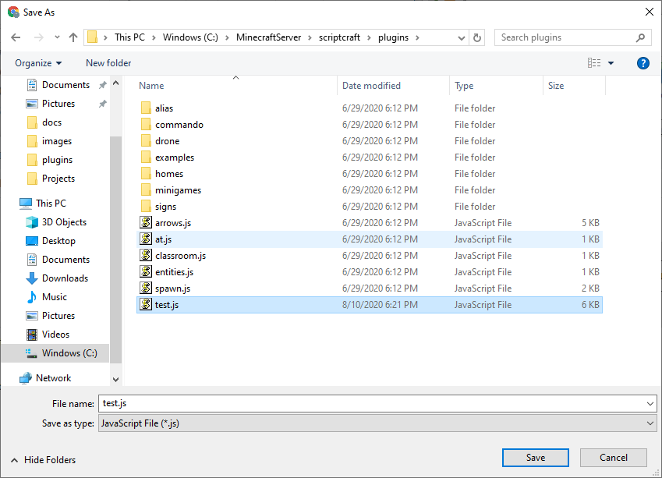

Next, after starting the minecraft server and joining localhost, in the minecraft game type: /reload followed by /js test(). You should then see a message from the server.

Class 3:

Console Output

Modify the above code by using the console output block instead of the send Message block.

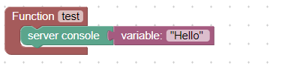

Enter the minecraft commands: /reload, /js test(). The message should then appear in the server console:

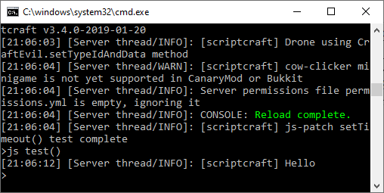

Player Mouse Click Event

The Player Mouse Click event triggers whenever a player left or right clicks their mouse.

This code will write to the server console when the event occurs:

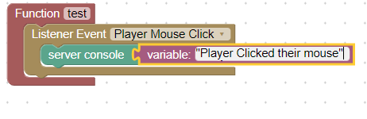

Class 4: Stacks and Lists

Individual items in minecraft are considered stacks of 1.

Stacks are found in Items Stack:

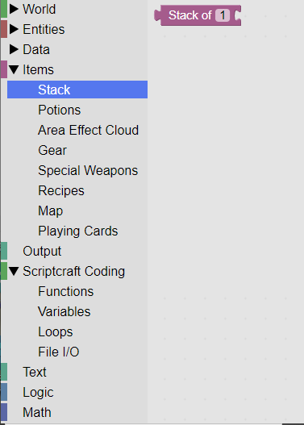

To give your item a custom name, use the custom name of stack block found in Items, Stack:

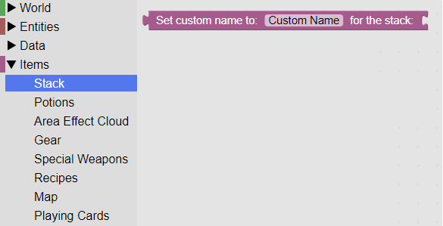

This code will create a custom sword called "Excalibar" and drop it at the player's location:

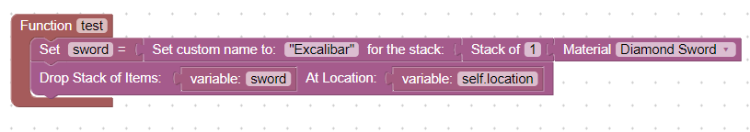

Class 5: Block Break Event and For Each Loop

In order to protect your world the block break event must be cancelled. This keeps players from destoying any structures.

This code will protect your minecraft world:

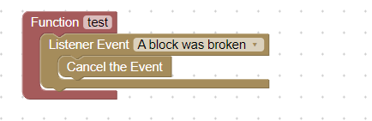

In order to test the code, press on the download button, then inside the minecraft game issue the commands: /reload, /js test() and attempt to break a block.

The block break event should be cancelled and the block restored.

Class 6: Respawn Event, and Event Information

The respawn event is triggered after a player dies and they respawn into the game.

This is a good time to teleport them to a lobby.

Create a lobby, and use the F3 command to determine the XYZ location of the lobby.

Modify the X, Y, and Z location of this code to match your lobby location:

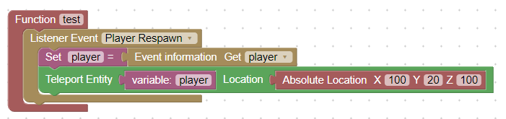

Press the download button and replace the test.js file. Then issue these commands from within the minecraft game: /reload, /js test().

Kill your player using the server command /kill @a.

When you respawn you should then be teleported to your lobby location.

Class 7:   
Entity Died Event, Get Custom name of stack

The entity died event is triggered whenever an entity is killed inside the game:

This code will write to the server console whenever an entity is killed:

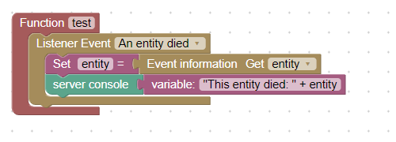

To test this code, press the download button and replace test.js, then within the minecraft game issue the commands: /reload, /js test() and then open the server console.

Messages will start appearing indicating that an entity was killed.

Class 8: Join Server Event

The join server event is triggered whenever a player reconnects to the server.

This code will teleport the player to a location when this occurs.

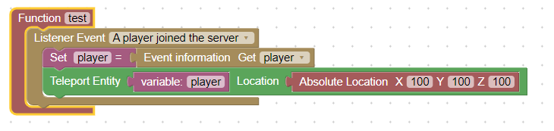

Change the X, Y and Z locations to point to your lobby. To test the code, press the download button, then within the minecraft game issue the commands: /reload, /js test() and then disconnect and reconnect to the local server.

You will be teleported to your lobby location.

Session 2 Custom Armor and Items

Class 9: Create a custom recipe

A custom recipe gives the player a way to create items that have a custom name. We then add code to test for this special name and activate abilities based on that name.

This code creates a recipe for "Excalibar":

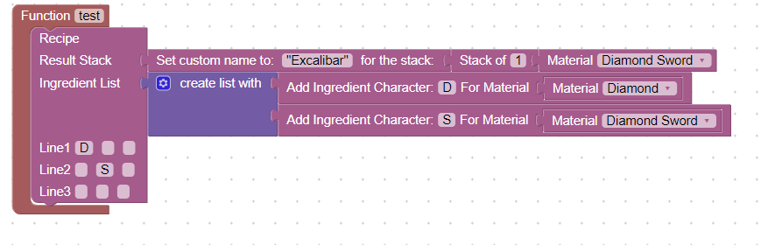

To test this code press the download button, and replace test.js, then within the minecraft game type the commands: /reload, /js test().

Give yourself a crafting table with the command: /give @a crafting_table 1, and give yourself some diamonds and a diamond sword.

You should now be able to create a diamond sword with the custom name "Excalibar"

Class 10: Other custom recipes

Now create other custom recipes for Potions, and armor.

Here is code for the creation of "Ice Boots":

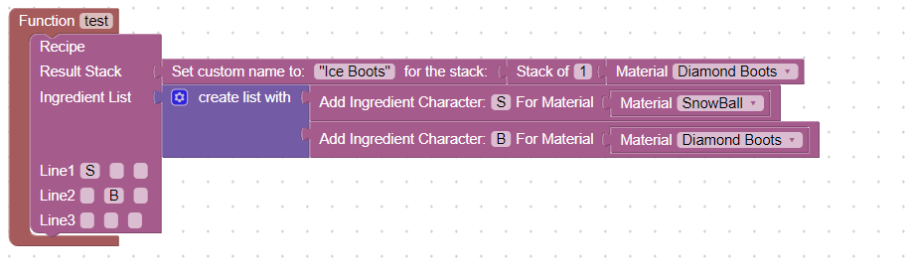

To test this code press the download button, and replace test.js, then within the minecraft game type the commands: /reload, /js test().

Give yourself a crafting table with the command: /give @a crafting_table 1, and give yourself some snowballs and diamond boots.

You should now be able to create diamond boots with the custom name "Ice Boots"

Class 11: Create a custom stack

All items in minecraft are considered a stack of items. This enables the program to display an item with a count in your inventory, such as a 64 stack of oak planks. If you just want to create 1 item it is still considered a stack of 1.

By giving our stack of 1, a custom name, we make the item "special". We can then write code to detect the custom name of the item, and activate an ability based on the name.

Here I will create a diamond sword with the custom name "Excalibar", and place it in position 1 of the player's hotbar:

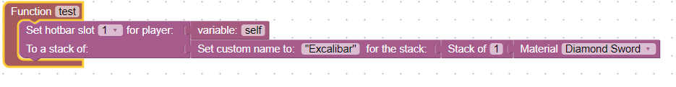

To test this code press the download button, and replace test.js, then within the minecraft game type the commands: /reload, /js test(). You should see the sword appear in slot 1 of your hotbar:

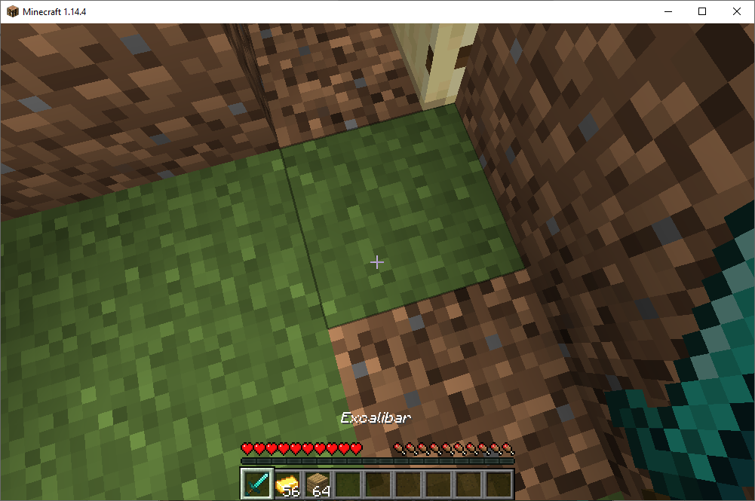

Class 12: Other custom stacks

Create boots, leggings, chestplate and helmets with different names based on process described previously. Here is an example of custom boots called "Jump Boots":

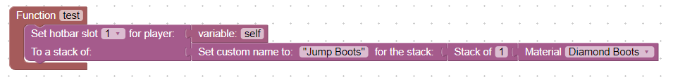

To test this code press the download button, and replace test.js, then within the minecraft game type the commands: /reload, /js test(). "Jump Boots" should appear in slot 1 of your hotbar.

Class 13: Drop an item

Dropping an item allows a player to pick it up. This code will drop a pair of diamond boots with the custom name of "Ice Boots". The location of the boots will be the same location as the player who is executing the /js test() command.

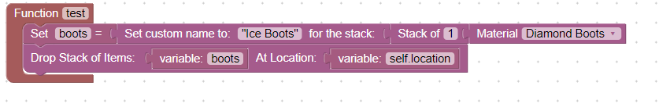

To test this code press the download button, and replace test.js, then within the minecraft game type the commands: /reload, /js test(). A pair of diamond boots with the custom name of "Ice Boots" should be added to your inventory.

Class 14: Other drop events

Drop other items such as potions and weapons.

This code will drop a sword with the name: "Kill Aura"

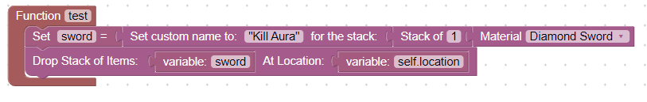

To test this code press the download button, and replace test.js, then within the minecraft game type the commands: /reload, /js test(). A sword with the custom name of "Kill Aura" should be added to your inventory.

Class 15: Determine what is in a player's hand

In order to activate special abilities of our weapons we need to know when the player is holding them. To do this we will use the inhand block. This code will write to the server the custom name of the item in the player's hand when they click their mouse.

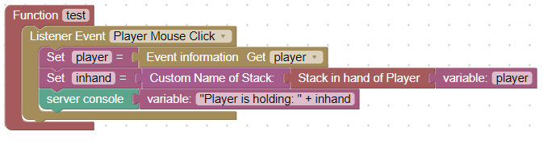

To test this code press the download button, and replace test.js, then within the minecraft game type the commands: /reload, /js test(). Place a custom named item in your hand and click the mouse button. The name of the item will then appear in the server console.

Class 16: Determine what armor the player is wearing

By checking what leggings, boots, chestplate or helmet the player is wearing, we can get the armor's custom name. We can then activate special abilities based on the custom name of the item.

This code will determine the custom name of the boots that the player is wearing and write that name to the server console.

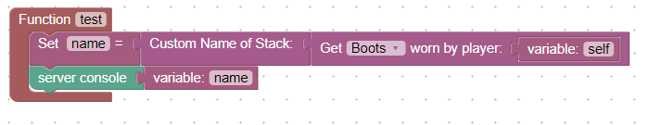

To test this code place special boots on your feet, press the download button, and replace test.js, then within the minecraft game type the commands: /reload, /js test(). I was wearing "Ice Boots" on my feet and the server console looked like this:

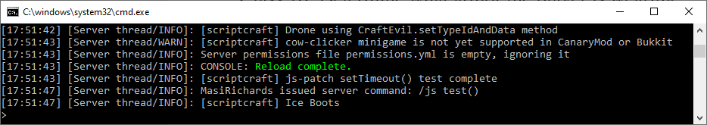

Session III - Building your maze game plugin

Class 17: Saving the project files, call function  
 We will be building a complete maze minigame plugin, so you will need to save the project file as you go. To save your current blocks click on the "Save" project file:

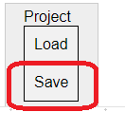

Then save the file with a descriptive name such as: "mazeProject.xml":

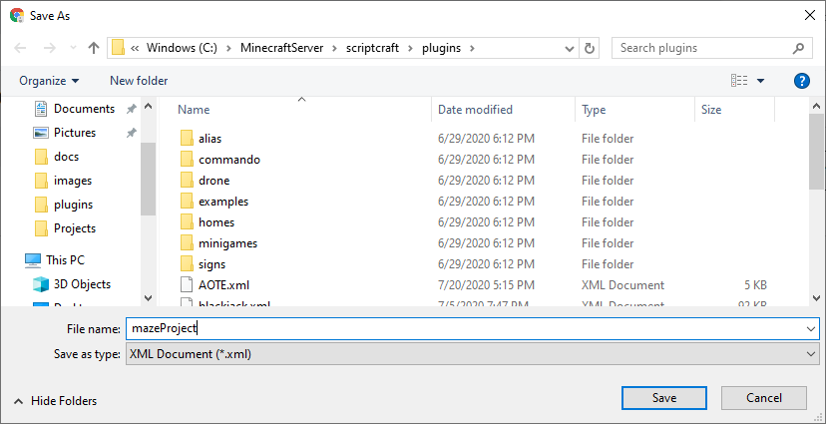

Remember to save after major changes. If you ever need to reload press the Load button:

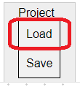

Sometimes it is good to organize code and place certain code together in their own function. For example I could save all my recipes in a function makeRecipes:

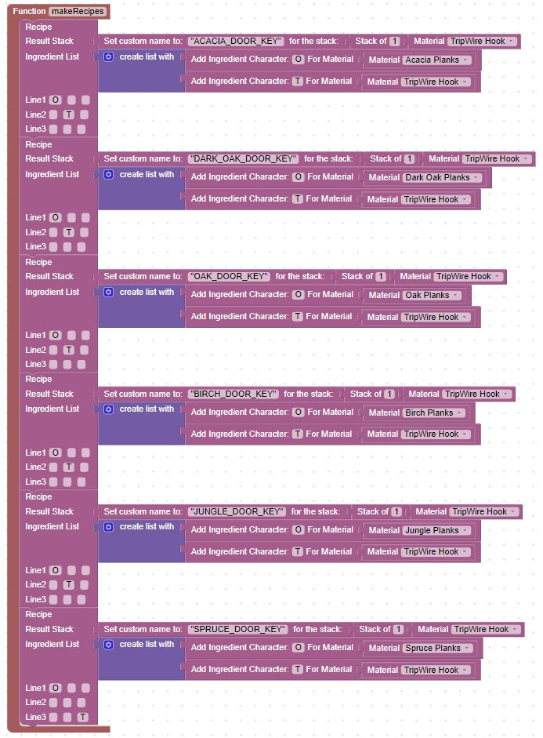

Then to call this function I would use the call function block found in Scripcraft Coding, Functions:

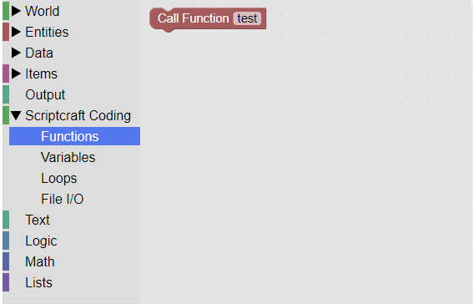

Class 18: Adding Doors and Keys

The first part of our maze consists of many connected rooms each with a door that requires a key. In order to "lock" the doors, special code is required to test the door on a player click and cancel the event if the proper key is not in hand.

This code will handle any door and open the door only when the appropriate key is held.

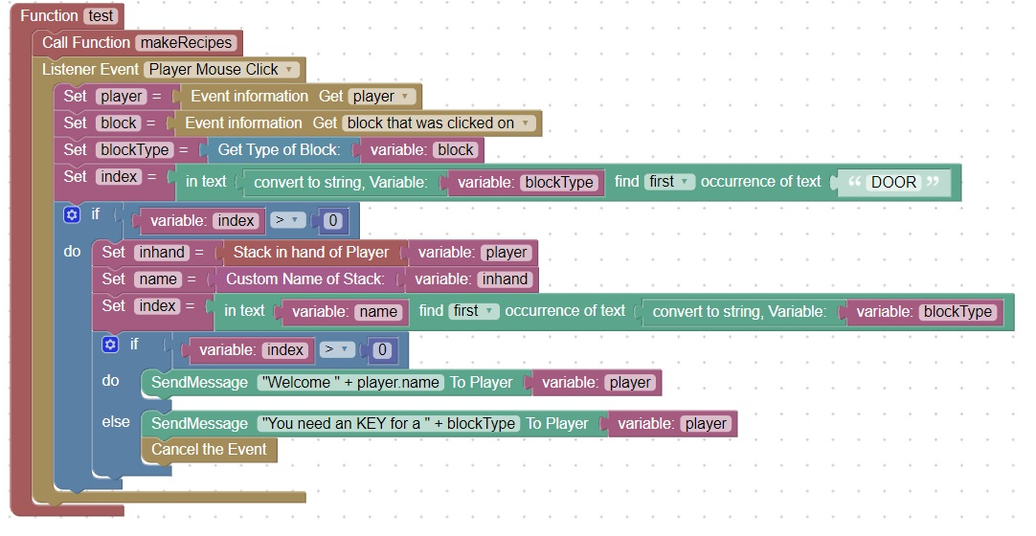

To test this code, create a key (tripwire-hook) with a custom name which includes the name of the door. For example a key that opens an oak door would have the custom name "OAK_DOOR_KEY". Then attempt to open an oak door when the key is in hand. The door should open. Now attempt to open or close the door when the key is NOT in hand. The door should not open or close.

Class 19: Adding obstacles that require custom items

In one of the rooms, fill it with lava.

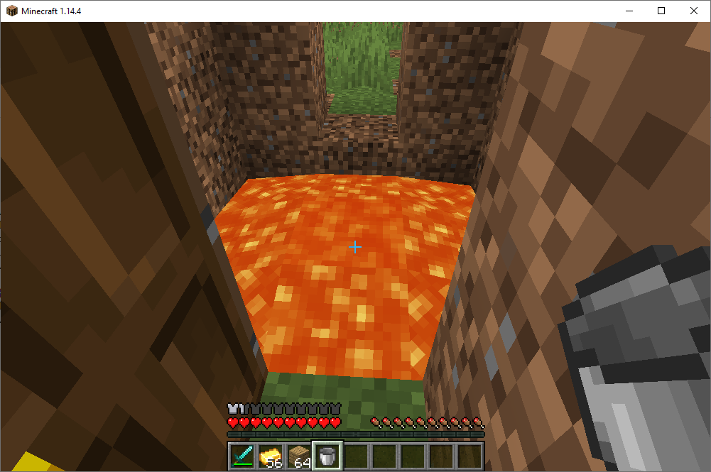

Create custom boots called "Ice Boots".

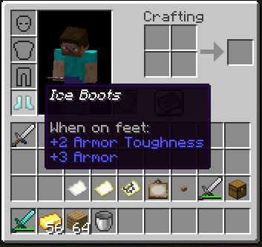

This code will turn the lava into ice when the player wearing ice boots walks on the lava.

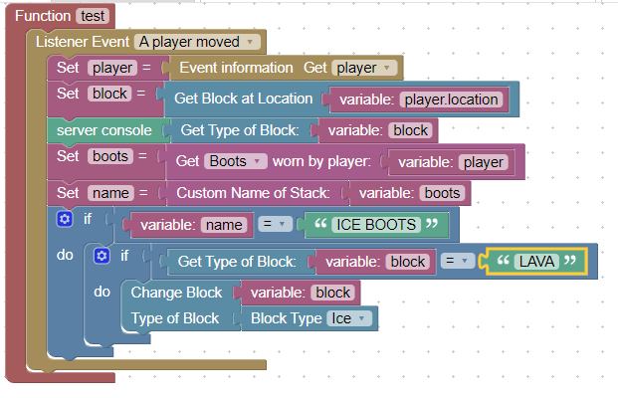

The lava will then look like:

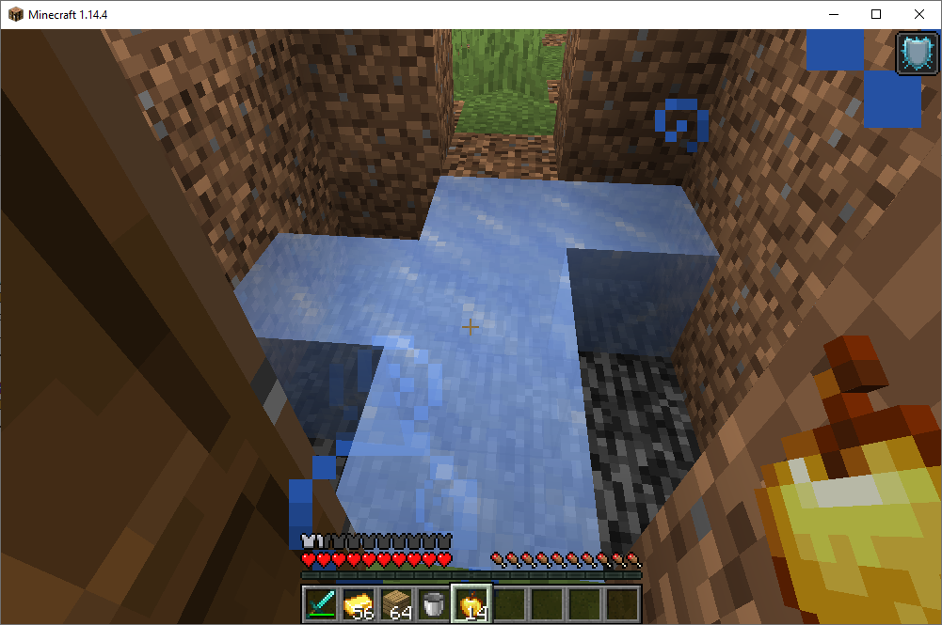

Class 20: Coding a boss monster

A boss monster is a great way to provide loot to players. However you may want to add boss monsters that are not defeatable and just annoy players when the enter a room. Here is the code for a witch boss monster:

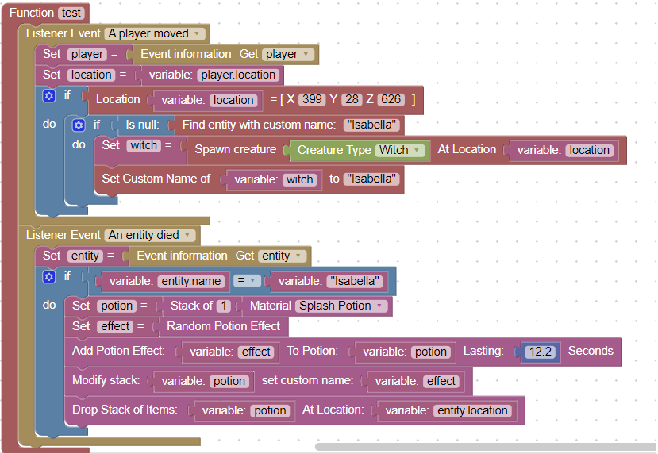

Notice that she will only appear once when the player reaches a specific [X,Y,Z] location

Class 21: Other boss monsters

In this class session we will add other boss monsters to the maze such as a wither. We may only want the wither to appear when a player enters the room, and then to disappear when the player exits the room.

Use your imagination to come up with other boss monster combinations. For example you could have a room filled with water, and a chest at the bottom of the water. The water could also be filled with Guardian boss monsters which do not drop any items, but only annoy and hurt the player.

Add a special helmet to your gear that allows underwater breathing to make this obstacle easier to accomplish.

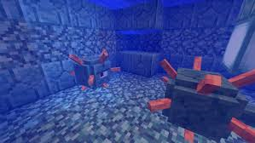

Class 22: Join Server, Respawn

The Join Server and Respawn events direct players to the correct [X,Y,Z] location when they join your server or respawn. When these events trigger you will want to transport the players to the beginning of your maze.   
This code will send a player to the beginning of my maze. Use F3 to determine the [X,Y,Z] location of your maze:

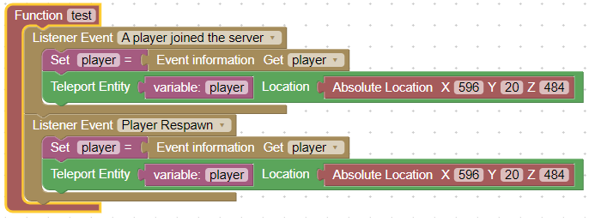

To test this code, disconnect and reconnect to your local server. You should be teleported to the start of your maze. Also kill yourself with the server command /kill @a, when you respawn you should also be teleported to the beginning of your maze.

Add this code to your maze project code.

Class 23: In game payment options

Some gear you may want to have the player pay for from a vending button.

Create an oak button with a sign above the button indicating which item the player can purchase and its cost:   
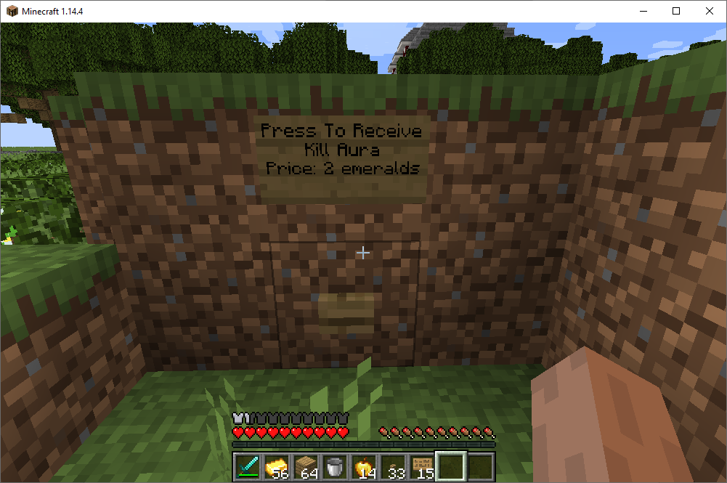

Then on player mouse click check the location of the button. If the location of the mouse click matches the location of your button, count the number of emeralds in the players hotbar. If they are greater than 2, clear the emeralds from the hotbar and drop a sword with the custom name: "Kill Aura".

This code will clear 2 emeralds from the hotbar if they can be found in the hotbar:

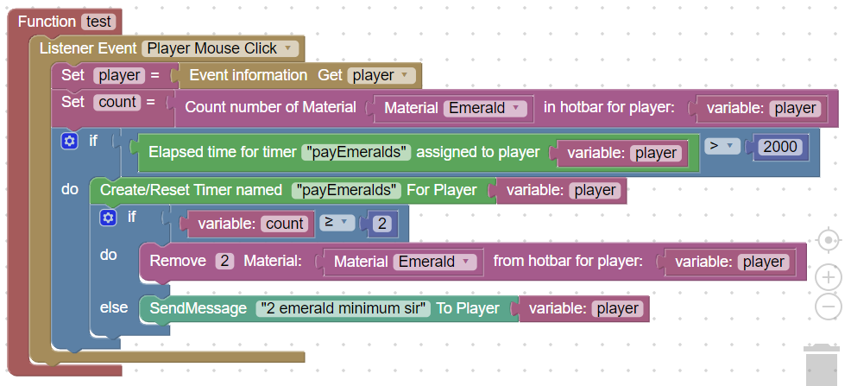

If the emeralds cannot be found, a message is sent to the player: "2 emerald minimum".

Class 24: Adding your code to a public server

There are [many public minecraft servers available](https://www.google.com/search?q=minecraft+server+rent&oq=minecraft+server+rent&aqs=chrome..69i57.8933j0j8&sourceid=chrome&ie=UTF-8). Most are very similar.  
It all comes down to cost versus playability  
Here is the price chart for apexminecrafthosting.com:  
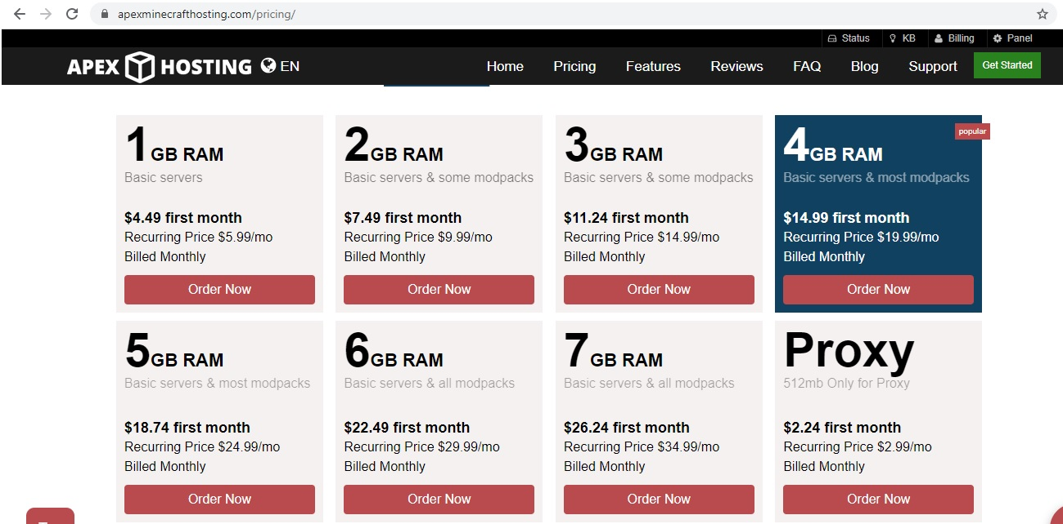  
Servers use file transfer protocol (FTP) to move files from your personal computer to the web-site:  
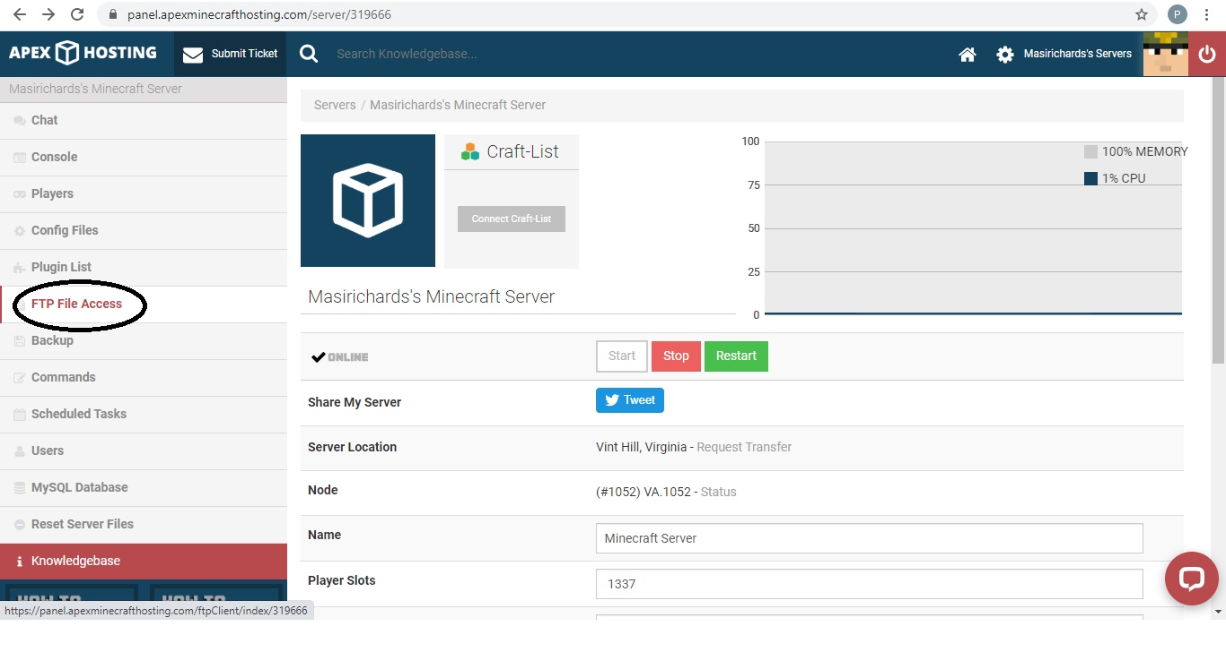

You need to copy scriptcraft.jar to the plugins directory, and copy over the files in your world directory  
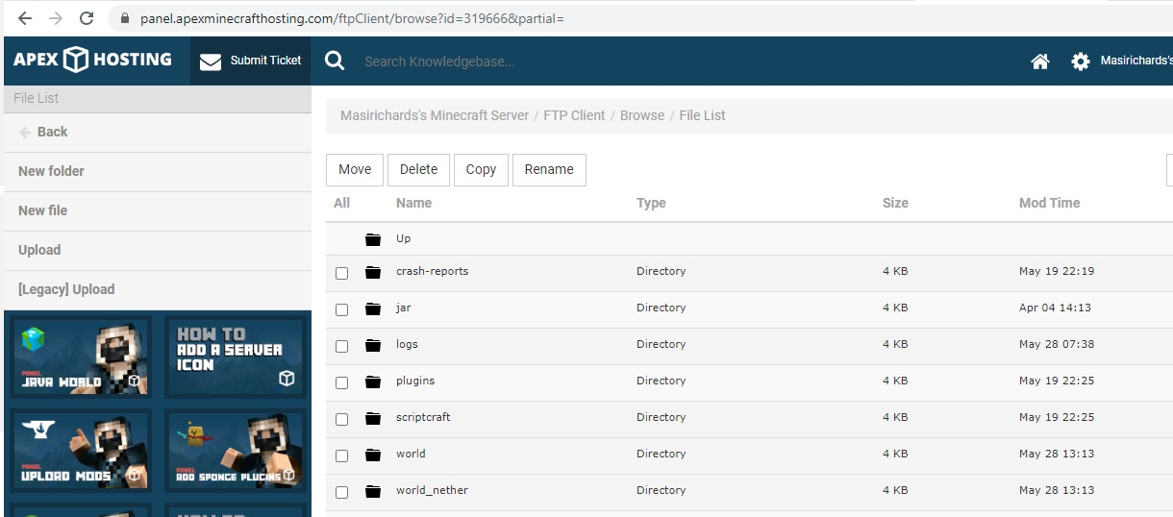  
Then use the console to restart the server

